CS-330  
1/16/2022  
John Ainslie

Module 2

Here are the images that I choose. I took the picture myself from two different angles and a separate picture for the background.

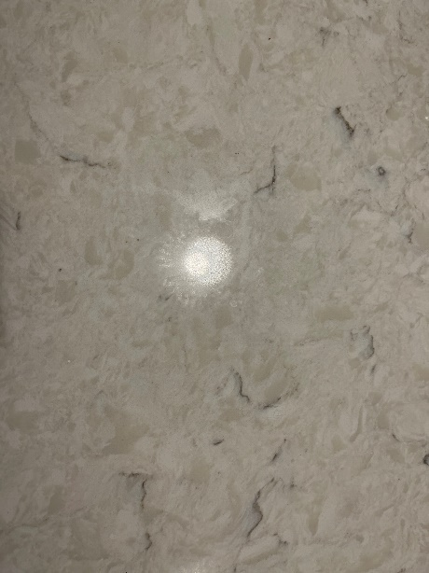

I would use a plane for the background image. For the book and charger, I would choose cubes. For the charger prongs I would use cubes for them too. For the pin I would choose a cylinder. For the bottle opener I would combine a torus and a cube.

I would start building with the background plane and then add the object to it. The hardest object to fit would probably be the bottle opener as it isn’t a perfect circle so it may require using two torus to best represent the object. The rest of the object are basic so shouldn’t be an issue.